How to get to ZALF

Address
​Leibniz Centre for Agricultural Landscape Research (ZALF)
Eberswalder Straße 84
15374 Müncheberg/Germany
Telephone: +49 (0)33432 82-441
Fax: +49 (0)33432 82-223
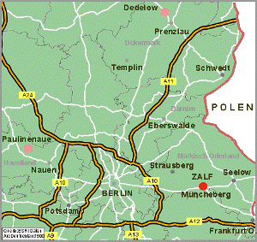
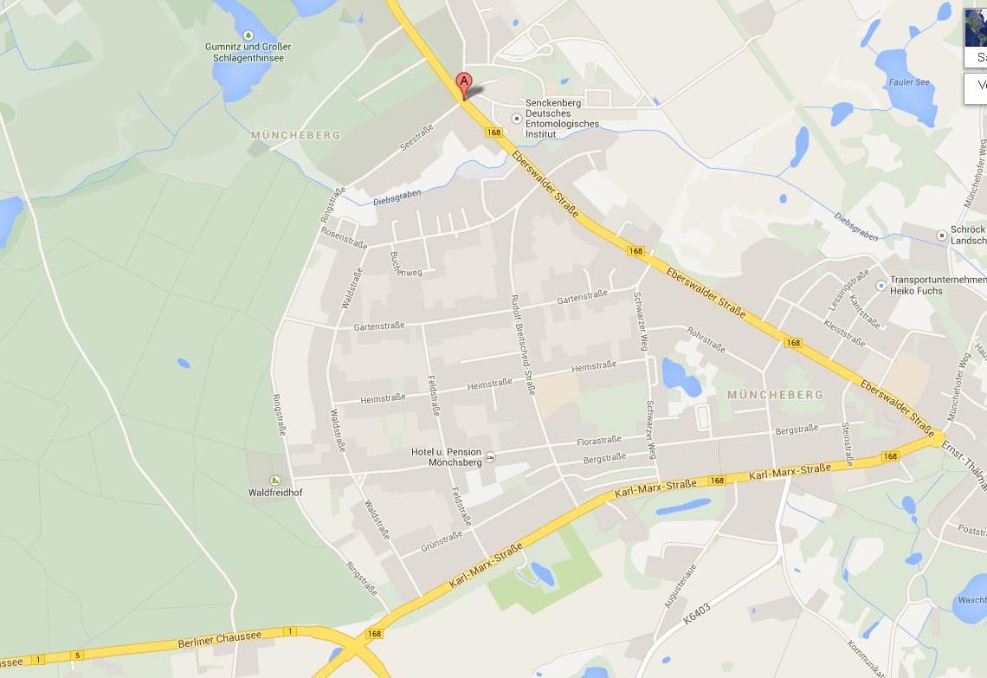

By car
From Berlin, take federal highway 1 towards Frankfurt (Oder) and exit at Müncheberg, then continue for around 3 km towards Eberswalde. You will see ZALF to your right.

By train
From Berlin Hauptbahnhof (main train station), take the S5, 7 or 75 suburban railway and change at Berlin-Lichtenberg to the regional train NE26 to Müncheberg. Trains are leaving in Berlin-Lichtenberg every hour (-:37).
Next to the railway building in Müncheberg, take bus 939 towards “Müncheberg-Stadt”. Get off at the bus stop "Müncheberg, ZALF" (one stop). From train station Berlin-Lichtenberg to ZALF your journey will take 38 minutes.
Plan your journey on: www.bahn.de

Hotel booking

We pre-booked several rooms for you. Please, use the word ZALF for reservation. There is only a limited allocation of rooms available until January 8, 2014.

Hotel Vier Jahreszeiten Buckow

Price: 40,00€ per person / night + 10,00 € for breakfast

http://www.vierjahreszeiten-buckow.de/

Buckow is a beautiful little village about 10 km away from Müncheberg. There will be a bus shuttle between the hotel and ZALF on the 17th and 18th.

On Sunday February 16, 2014 the last bus (line 928) from Müncheberg train station to Buckow is leaving 19:30. Taxi: 0049(0)3343289543

Motel One Berlin-Alexanderplatz

Price: 69,00€ per person / night + € 7,50 for breakfast (Feb 16th to 17th)

89,00€ per person / night + 7,50€ for breakfast (Feb 17th to 18th , trade fair rate)

http://www.motel-one.com/de/hotels/berlin/hotel-berlin-alexanderplatz/
You can reach ZALF by train or car from the hotel (see above “How to get to ZALF”). From train station Berlin-Alexanderplatz to ZALF your journey will take 1:02h.

